**Exploring the Southern Sierras: Water, snow & ecosystem monitoring across the range**

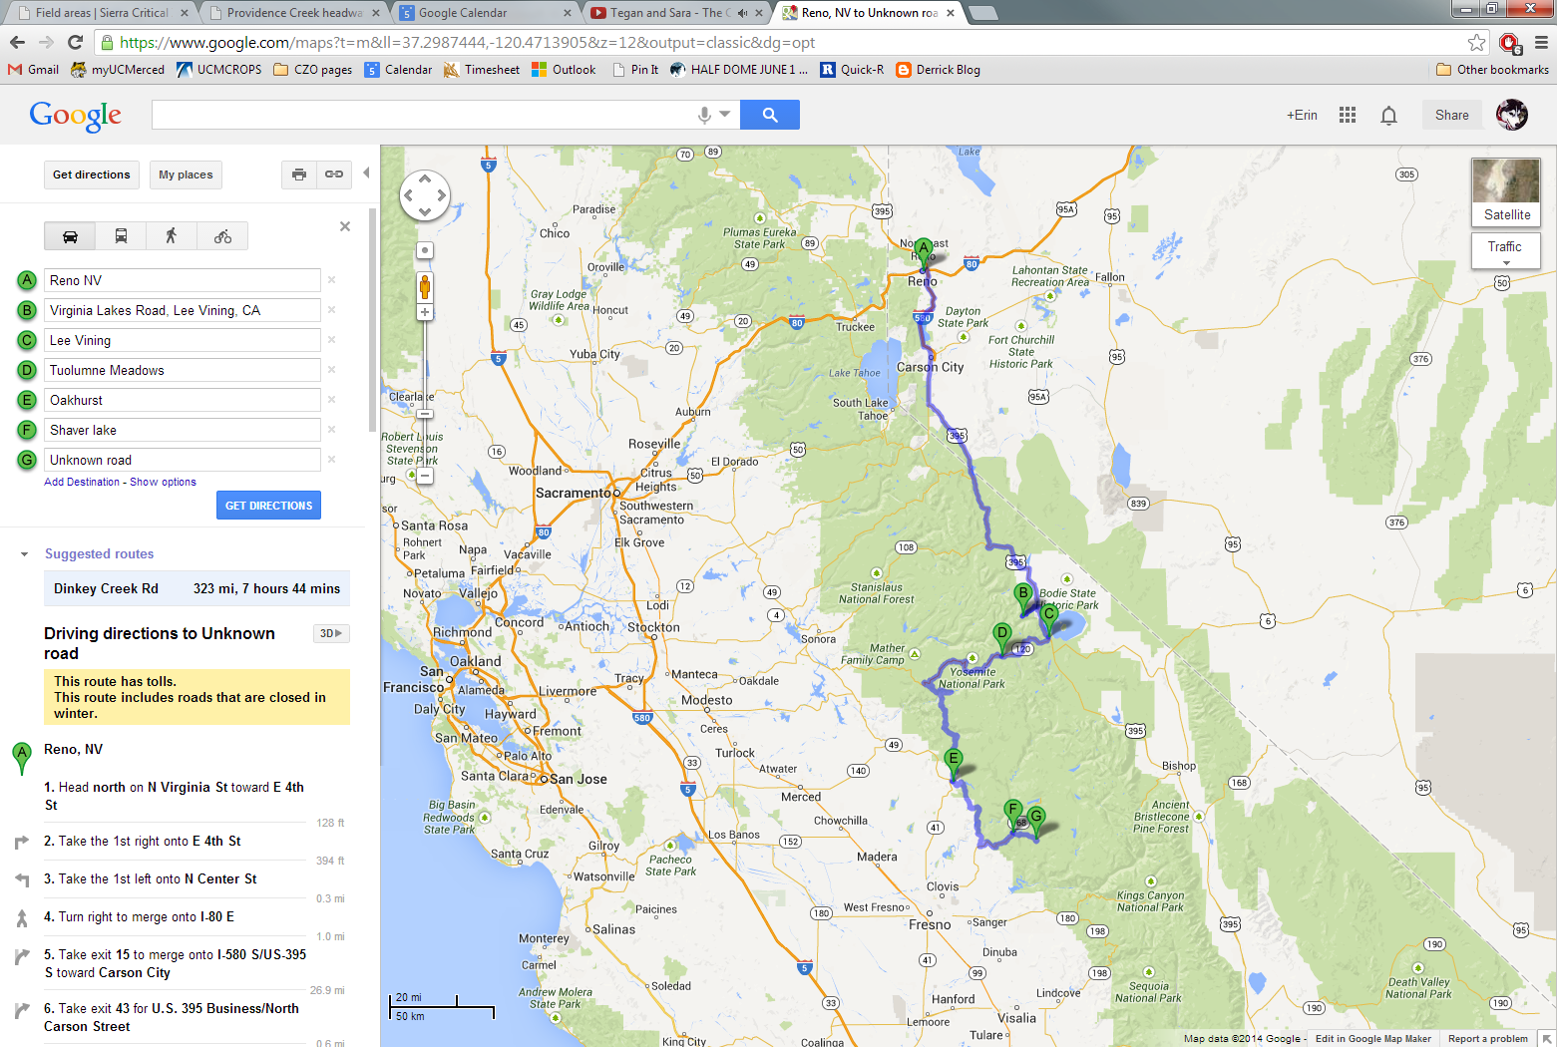The Sierra Nevada marks the geographic boundary between the great Central Valley of California to the west and the Basin and Range province to the east. The range comprises diverse ecosystems: traveling from west to east, you encounter rolling oak woodlands, dense montane coniferous forests, alpine meadows and peaks, and back down to Pinyon pine-Juniper forests and scrublands on the eastern face of the range. In this semi-arid climate, snowpack accumulation in the mountain range constitutes a critical resource for the larger region. Runoff from the Sierras is used by more than 10% of the population of the United States. Sierra Nevada runoff also sustains agriculture in the Central Valley of California, a multi-billion dollar industry providing a considerable portion of the country's produce. Research on hydrology, climate, and ecosystem interactions in this region has immense implications for regional livelihoods and policies.

To study these topics in the Sierra Nevada, there are several long-term monitoring sites scattered across the region. This trip will give you a first-hand look at many of the sites, including the SNOTEL installation at Virginia Lakes Ridge, the GLORIA monitoring site, long-term collaborative monitoring of the Mono Basin , the Southern Sierra Critical Zone Observatory, and monitoring efforts by the National Park Service Inventory & Monitoring Program at Yosemite National Park. The trip will take approximately 3 days and include travel to elevations as high as 10,000’/3048 m (as well as an optional hike to near 11,000’/3353 m).

Finally, a large portion of the Sierra Nevada is federally protected land. On this trip, participants will see parts of the Humboldt-Toiyabe, Inyo, and Sierra National Forests, as well as Yosemite National Park. After the trip, you will be in a great location to hike or camp in the Sierra National Forest, or in Yosemite, Sequoia or Kings Canyon National Parks. Participants may wish to schedule private trips for camping or hiking at the end of the organized field trip. Trips to mid-to-high elevation sites at this time of year are ideal.

Figure 1. Approximate trip route. The planned route from Reno (A) is to head south along the eastern side of the Sierras to Virginia Lakes Ridge SNOTEL site (B) as well as the GLORIA target region, staying that night in Lee Vining (C). A short stop at Mono Lake follows the next morning before heading into Yosemite National Park to examine installations at Tuolumne Meadows (D), Gin Flat, or surrounding areas. For the second night, accommodations will be in Oakhurst (E) before heading towards Shaver Lake (F). Stops in this area include the San Joaquin Experimental Range, as well as CZO installations at Providence Creek (G).

**Destination**: multiple sites in the southern Sierra Nevada

**Duration**: July 20-22

**Transportation**: Provided vehicles

**Lodging**: Motels at Lee Vining, Oakhurst or Shaver Lake

**Estimated cost: $460 per person** Access online registration at [criticalzone.org/sierra](http://criticalzone.org/sierra/news/story/exploring-the-southern-sierras/).

**Day 1 (Sunday, July 20)**: Depart Reno at 8:30 am, arrive Conway Summit at 11 am.

A short detour to Virginia Lakes area (5 mi), where a bag lunch is planned. Afternoon in that area:  visit Virginia Lakes Ridge SNOTEL site and discuss long-term monitoring of the SNOTEL program (Dave Simeral).

Participants will also view & discuss the Mt. Dunderberg GLORIA target region, now in its 10th year of monitoring alpine plant response to climate change using international GLORIA protocol (Connie Millar).  A subparty could walk to the low summit site (2 hrs), others can either wander in area or continue to Mono Lake for free time (15 minutes from Conway Summit).

Dinner and motel in Lee Vining

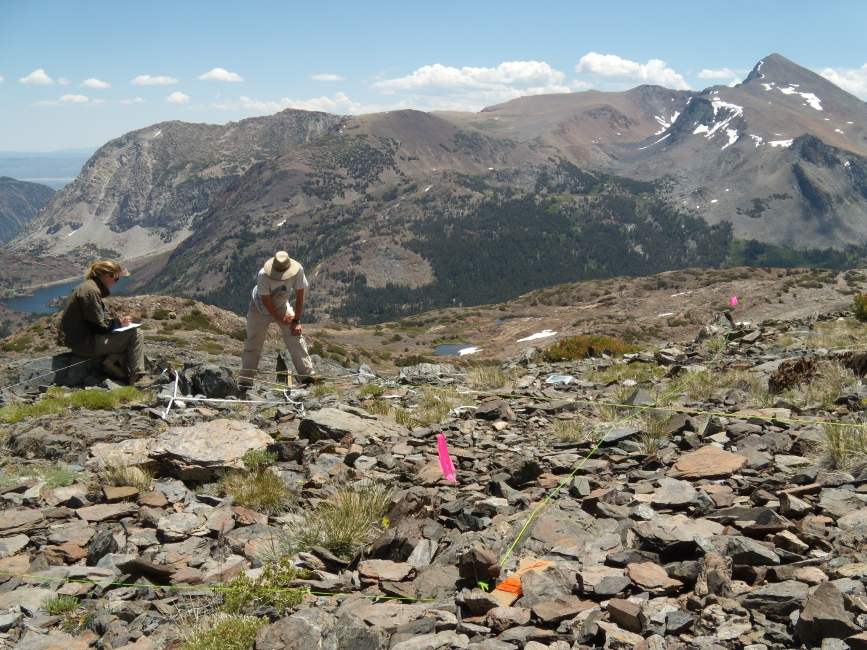

Figure 2. GLORIA monitoring plots on a ridge near Mt. Dana and Tioga Pass. The Gaylor Lake & ridge hike (Day 2) lies nearby.

**Day 2 (Monday, July 21):**

On Monday morning, depart at 8:00 for the first stop, which will feature watershed monitoring and restoration of Mono Lake ecosystem.  Over 35 years monitoring many components of the Mono Basin ecosystem (eco/hydro/climate), with the last 20 years focused on monitoring, in particular for ecosystem restoration (Greg Reis, Mono Lake Committee).

Leave at 11:30 am and drive to Tioga Pass for a discussion on the climate station over a bag lunch, with an overview of the climate monitoring network in Sierra/White Mountains. Following lunch, some participants may choose a short invigorating hike from Tioga Pass to the ridge by Gaylor Lake to enjoy the view and hear about the NPS Sierra Nevada Network's monitoring projects at Yosemite and other national parks. Others who prefer not to hike will go to Tuolumne Meadows and hear about Sierra Nevada Network monitoring and research projects by NPS researcher Jim Roche.

Depart Tuolumne Meadows by 4:30 pm at latest. Dinner at Wawona & lodging in Oakhurst.

**Day 3 (Tuesday, July 22):**

Depart at 7:30 and drive 30 minutes to San Joaquin Experimental Range. Presentations by researchers with Southern Sierra Critical Zone Observatory (CZO) and NEON.

At 10 am, depart and head for Providence Creek site ( 1 hour travel time) for the Southern Sierra CZO. Otherwise (if staying in Shaver Lake) depart at 8:30 and head for Providence Creek. There, visitors will see the heavily instrumented Critical Zone Tree, the tallest flux tower in the CZO transect (at 50 m in height), and an extensive wireless sensor network.

Afternoon will include a hike up Bald Mountain *(may adjust to spend more time at Providence; especially to observe recent thin & burn treatments).* The hike is approximately 75 minutes each way.

Dinner & lodging in Shaver Lake is optional, though must be pre-booked (Participants are free, as of the evening of July 22, to continue onto other trips or head for the airports at Fresno, or elsewhere)

**Contacts:**

Erin Stacy, Southern Sierra CZO (estacy@ucmerced.edu)

Connie Millar, Forest Service, GLORIA site (cmillar@fs.fed.us)

Alice Chung-MacCoubrey, NPS Sierra Nevada Inventory & Monitoring Program, (alice_chung-maccoubrey@nps.gov)

**Costs, Transport, Food and Accommodation**

**Trip Fee** covers lodging, food, and transportation. We will provide you handouts with maps of the trip locations and background information. There will be water and limited snacks on the trip – be sure to bring a water bottle! You are also welcome to bring additional snacks to tide you over between meals.

**Food** costs include lunch and dinner on Sunday (you will be on your own for Breakfast before convening). Breakfast, lunch and dinner will be provided on Monday. Breakfast and lunch will be provided on Tuesday. We will be ordering packed lunches from local cafes. If you have special dietary needs, please contact [Erin Stacy](mailto:estacy@ucmerced.edu) for further options.

**Accommodation** We will be staying in Lee Vining on Sunday night and in Oakhurst on Monday. Prices reflect double occupancy – if you would prefer single occupancy, please contact [Erin Stacy](mailto:estacy@ucmerced.edu) to arrange for an additional fee. We can help coordinate reservations in Shaver Lake on Tuesday night if you would like to stay after the trip; you would transmit payment directly to the hotel.

**Cancellation Policy**

To comply with booking and cancellation policies of our partners, we will abide by the following cancellation policy for the Sierra Tour Trip for the 2014 MRI Global Fair and Workshop.

* Trip booking deadline is June 20 – all participants must be registered and trip fees paid by 12 pm PST, June 20, 2014.
* Cancellations are allowed up until this point (12 pm PST, June 20, 2014) for a refund of your trip fees, less 2% ($450).
* Late cancellation will be accepted until 11:59:59 pm PST, July 2, 2014. You will receive a refund of half of the trip fee (50% refund, for $230).
* No refunds will be made for any cancellations starting July 3.