**Drilling, sampling and imaging regolith.**

**What controls the thickness and (relevant?) chemical and physical properties of regolith?**

**What is the relative importance of climatic, biotic and geologic factors in regulating regolith properties?**

1. approach:
   1. climate transect
      1. Drilling at SJER, Soaproot, and SSCZO.
      2. geophysics
   2. “drilling”
      1. for now geoprobe: provides cores
      2. in future: rotary drilling – get into
   3. geophysics; multiple methods; set to do some work in early
2. gaps, resource needs and opportunities
   1. plan: moving forward with drilling for 2013 have permit for SJER and Soaproot; have plan to do some geophysics early this fall probably at SJER.
   2. gaps
      1. sampling? how to do microbes (example of contamination)
   3. resource needs
      1. What we have…
         1. capitalize on WyCEHG (Wyoming Center for Environmental Hydrology and Geophysics) – Steve Holbrook signed a letter of collaboration for renewal proposal.
         2. Davis has geoprobe
         3. DOSECC has Winkie drill
         4. need human power

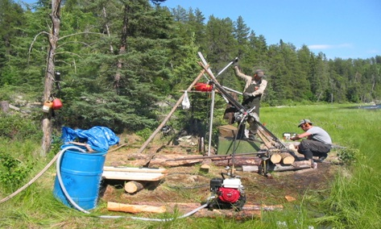

* 1. opportunities
     1. what to measure? Bulk geochemistry, porosity, wc, sample water for stable isotopes….  
        mineralogy?  
        biomarkers? lithotrophs?  
        what else?

1. cross CZO opportunities
   1. TBD at NSF Workshop… Me and Jon Chorover organizing…  
        
      Drilling, sampling and imaging the depths of the critical zone. Scheduled: October 24-26, 2013, in Denver CO.  
        
      Representation from all CZOs, plus others. Talks by experts in drilling and geophysics.  
        
      One outcome of workshop: a cross CZO proposal? An Eos article (call for action)?