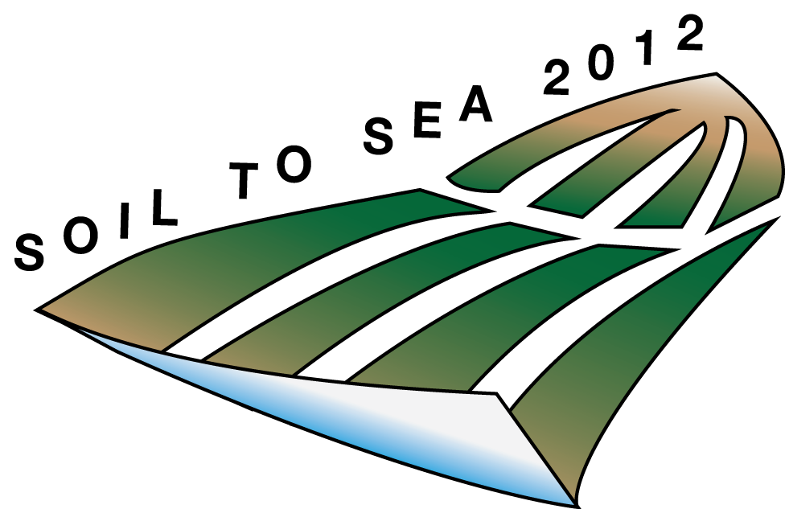

**Soil to Sea Geomorphology - 2013**

***May 17–18, 2013***

***The Johns Hopkins University, Baltimore, MD***

The aim of this symposium is to maintain and foster the Mid-Atlantic network of scientists studying all aspects of Earth-surface science. All scientists and research-oriented students who live within an Amtrak-ride from the conference venue and whose interests lie in the areas of quantifying rates of landscape evolution, mechanics of sediment transport and soil production, coastal processes and the sedimentary record, and response of landscapes to anthropogenic disturbances are encouraged to attend! Please, encourage your students and postdocs to submit an abstract and register.

***Registration is open! Simply confirm your attendance by e-mailing: amtrak.club@gmail.com***

1-page poster abstracts will be compiled and distributed. Housing is available through various hotels in Baltimore. The conference will host five thematic sessions with keynote speakers in each session. We are happy to confirm five outstanding keynote speakers:

*Mark Brandon (Yale), Pat Wiberg (UVA), Karen Prestegaard (UMD), Tess Thompson (VT), Enrica Viparelli (USC)*

***Important dates:***

Registration deadline….. May 1, 2013

1-Page Abstract deadline…. May 6, 2012

Inquiries and interest may be directed to the ‘AMTRAK Club’ organizing committee:

Doug Jerolmack ([sediment@sas.upenn.edu](mailto:sediment@sas.upenn.edu)), Ben Horton ([bphorton@sas.upenn.edu](mailto:bphorton@sas.upenn.edu)) ,  
Peter Wilcock ([wilcock@jhu.edu](mailto:wilcock@jhu.edu)), Jane Willenbring ([erosion@sas.upenn.edu](mailto:erosion@sas.upenn.edu)), and

Katie Skalak ([kskalak@usgs.gov](mailto:kskalak@usgs.gov))