Ground Penetrating Radar - Monitoring Soil Moisture

Introduction:

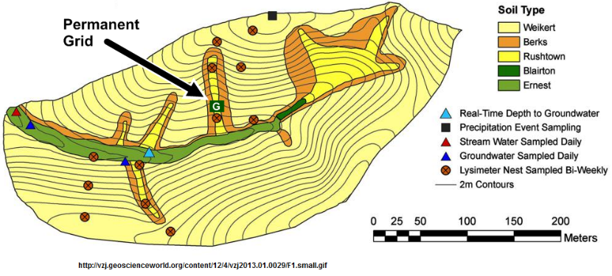
The Susquehanna Shale Hills Critical Zone Observatory is a forested watershed in Stone Valley in northern Huntingdon County, Pennsylvania. Owned by Penn State University, it is a field site for a diverse array of active research projects in, for example, soil science, geology, forestry, and hydrology.

Ground-penetrating radar (GPR) is a subsurface-imaging technique that uses high-frequency electromagnetic pulses. The Penn State GPR unit consists of 2 transducers. The first transducer transmits a 500 MHz electromagnetic wave into the ground while the second records the elapsed time for reflected waves to return to the surface. A display unit uses this data to create an image of the subsurface.

A permanent grid located in one of the south-facing swales at Shale Hills allows GPR surveys to be accomplished at a set site at different times. The grid consists of 13 rows or “transects” and is bounded on each corner by PVC pipes that each contain a soil moisture probe.

Goals and Objectives:

This activity explores methods for visualizing and understanding the relationship between plant features (biosphere), the development of subsurface water flow pathways (hydrosphere and lithosphere), and variations in soil moisture content through time. You will use data collected from the Shale Hills field site to accomplish the following objectives:
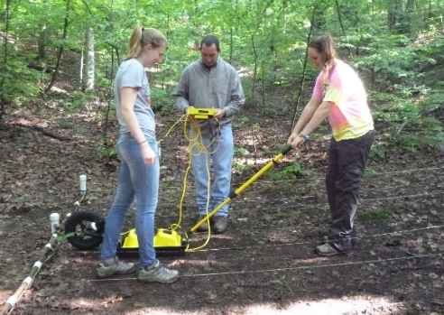
Next Generation Science Standards (NGSS) are noted in parentheses (http://www.nextgenscience.org/).

- Describe the relationship between GPR transmission-reflection delay times, wave speed of electromagnetic radiation, and soil depth. (HS-PS4-5)

- Interpret field data to infer the location of rocks, roots, and other point reflectors located in the subsoil. (HS-PS2-6)

- Compare time-lapse GPR field data with soil moisture measurements to describe the impact of surface rainfall on soil moisture changes at various depths. (HS-ESS2-5)
Part 1: Using Ground-Penetrating Radar to Detect Subsurface Features

On a GPR image, each object below the surface appears as a hyperbola due to repeated reflections produced as the GPR unit passes over an object. In the GPR image displayed in Figure 1, the left side of the image displays the total elapsed time between when the signal was transmitted and when it returned to the second transducer, while the right side shows the calculated depth of the object that reflected the signal. Complete the table based on the data provided in the GPR image.
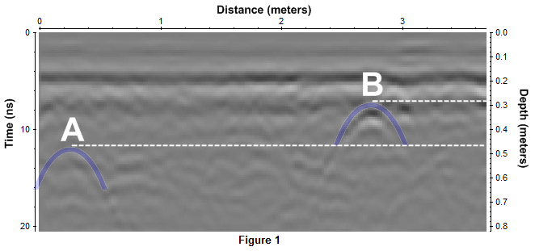
 | A | B
Travel time between transmitter and object (ns)
Depth of object (m)
Velocity of transmitted wave (m/ns)

Since this GPR image was taken of the forest floor, what object(s) may have created the reflections at points A and B?
→____________________________________________________________________________
Part 2: Ground-Penetrating Radar – Analyzing Soil Moisture

The GPR data presented in this section was collected at the permanent grid just before and after a significant rainfall event. In addition to GPR data, soil moisture percentage was measured using a time-domain reflectometry (TDR) probe. Figure 2 represents the layout of the permanent grid, including the location of the four corner sites where the TDR probe was used to measure soil moisture percentage. Data from the four TDR sites was averaged on each date and is displayed in Figure 3.
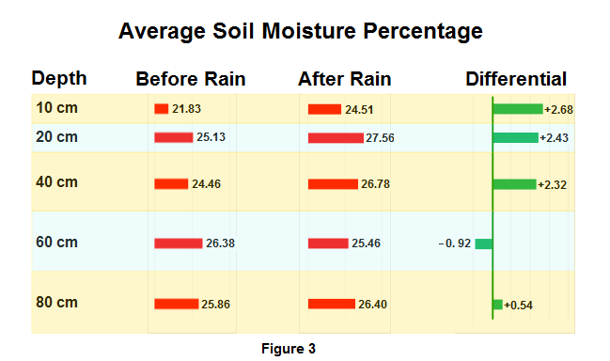
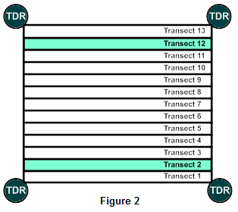

Processed and enhanced GPR surveys for the two highlighted transects in Figure 2 are shown below. Reflected signals are represented by bands of color. The sequence for each transect includes images recorded before and after the rainfall event as well as a third image produced by mathematically subtracting the first two images. By performing this operation on the data, the third image can be used to illustrate the change in subsoil characteristics due to the rainfall event.

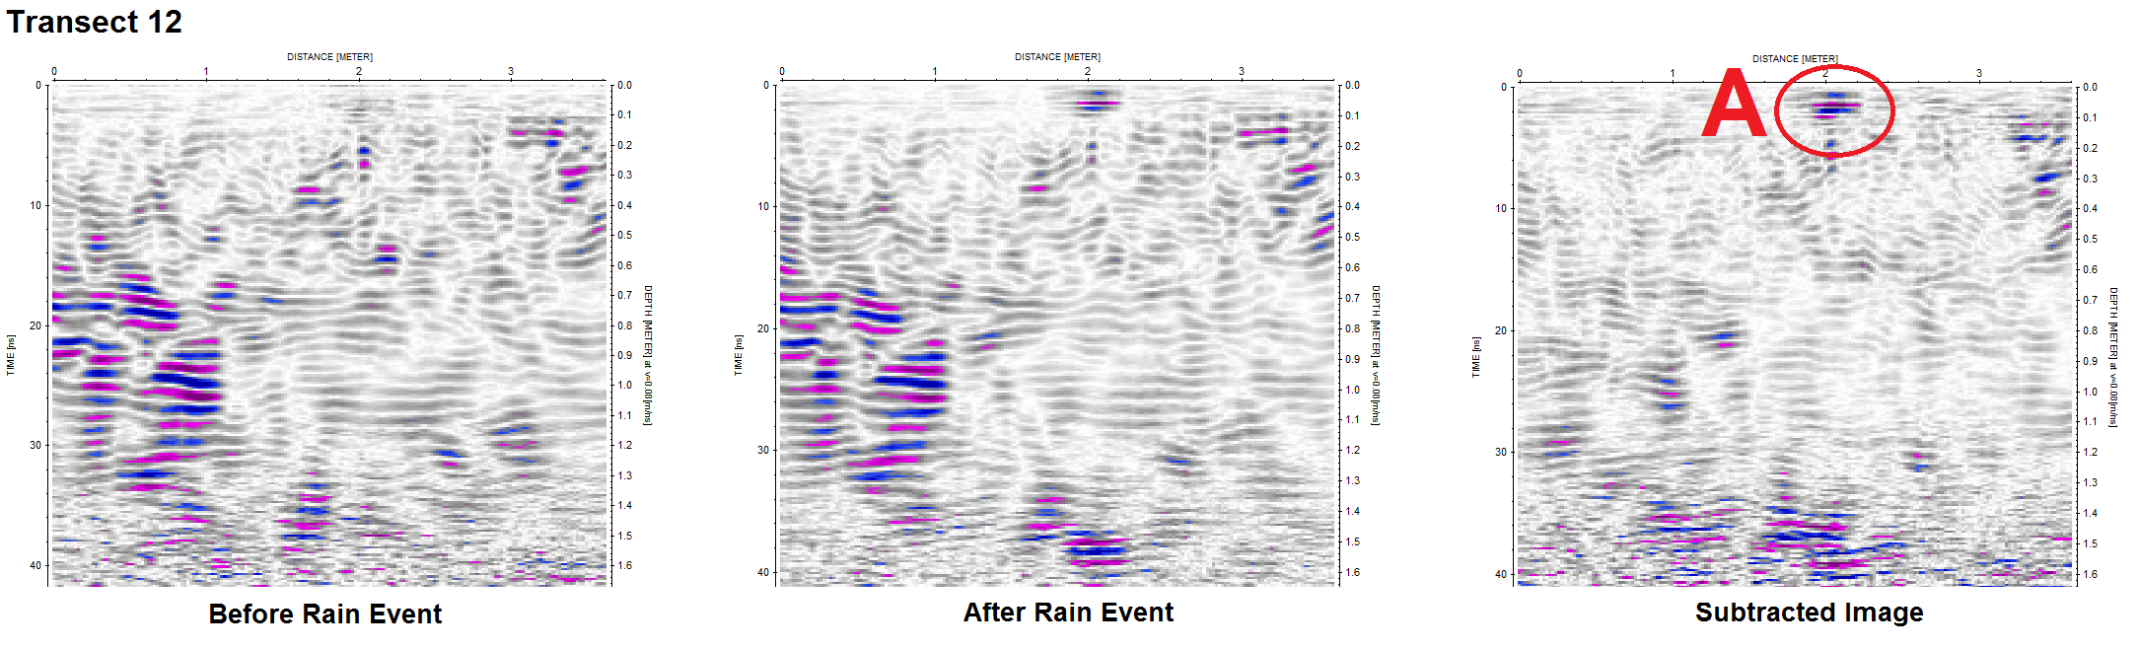

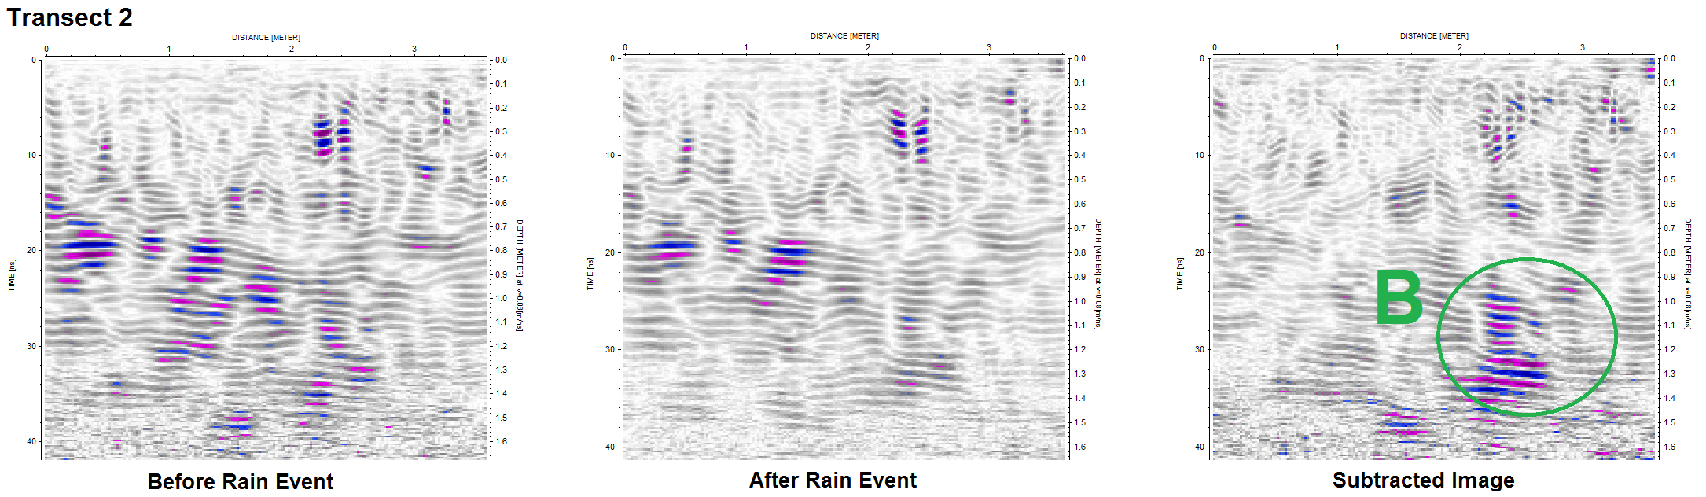

- What does the TDR data indicate about the effect of rainfall on the soil moisture at various depths below the surface?
- Describe the extent to which the data from each GPR transect is consistent with the TDR data.
- Explain what kind of feature could be responsible for the large increase in moisture at point A after the rainfall.
- TDR data indicates little change in moisture at depths below 40 cm, but there appears to be a large change in moisture at point B, which is at a depth of approximately 1.0 m. How might this be explained?
- In both images, something about the reflected energy changes at a depth of about 1.5 m. Why might this occur?

